Experiment 3

SINUSOIDAL MOTION: The Oscilloscope

APPARATUS: Cathode-ray oscilloscope, audio generator, step-down transformer, microphone and preamplifier.

REFERENCE: Rossing, The Science of Sound. Sections 2.1, 33.1-33.3.

DISCUSSION:

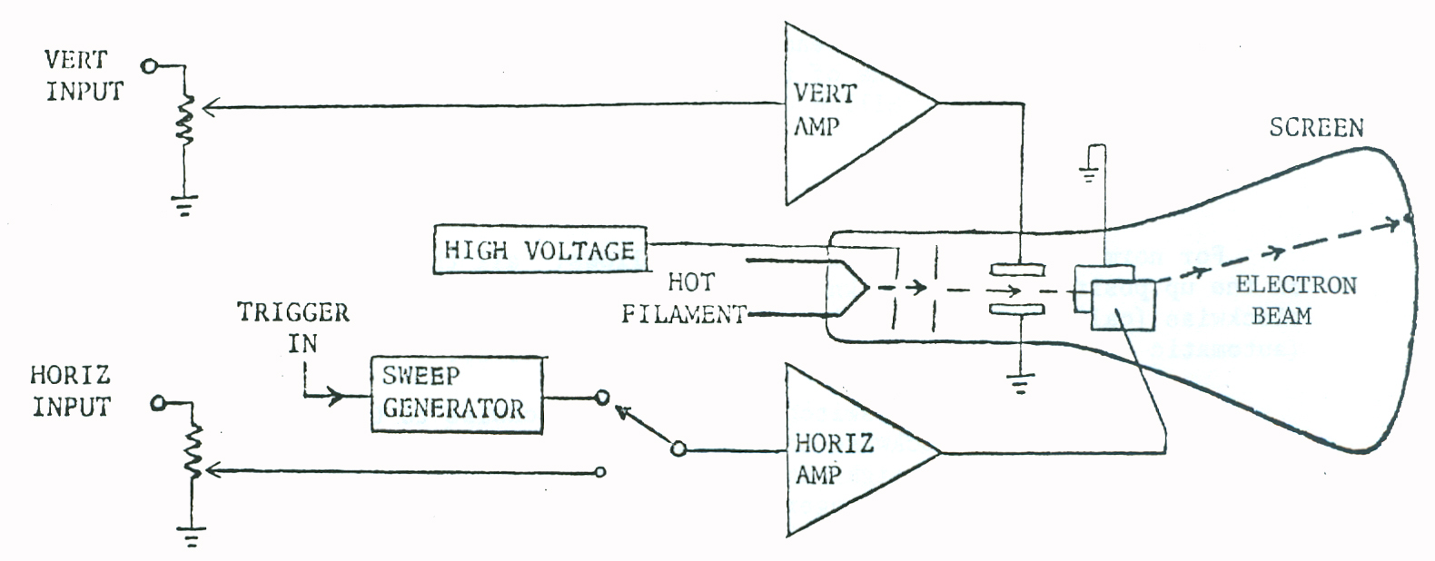

The cathode-ray oscilloscope usually performs one of two operations:

1. It displays one voltage as a function of another by applying one voltage to the horizontal plates and one to the vertical plates.

2. It displays a voltage as a function of time by applying a steadily increasing voltage (sweep) to the horizontal plates, so that the electron beam moves across the screen at a constant speed while it is deflected and down by a voltage from the vertical amplifier.

The most useful oscilloscope is one which has a calibrated sweep time, so that time can be obtained directly from the displayed pattern. The sweep time will usually read in seconds or milliseconds per centimeter of beam travel across the screen. By noting the length of one complete wave in cm and multiplying by the sweep time setting in S/cm, the period (in s) and hence the frequency (in Hz) can be determined. The vertical deflection should also be calibrated in volts or millivolts per centimeter, so the amplitude of the wave can also be determined from the oscilloscope picture. Another important feature is a trigger circuit, which automatically starts each sweep at the same point on the wave (similar to the “horizontal hold” of a TV set).
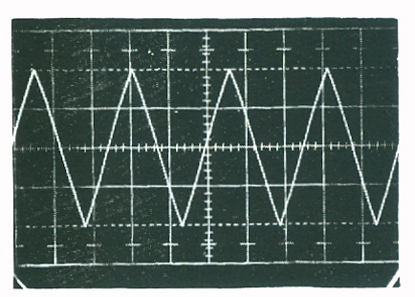

Shown at the right is a photograph of an oscilloscope display (called an oscillogram). The vertical calibrator was set at 2 V/cm and the time base at 5 ms/cm, so the total (peak-to-peak) amplitude is 4 x 2 = 8 volts, and the period is 2.6 x 5 = 13 ms. The frequency is the reciprocal of the period (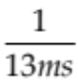) or 77 Hz.

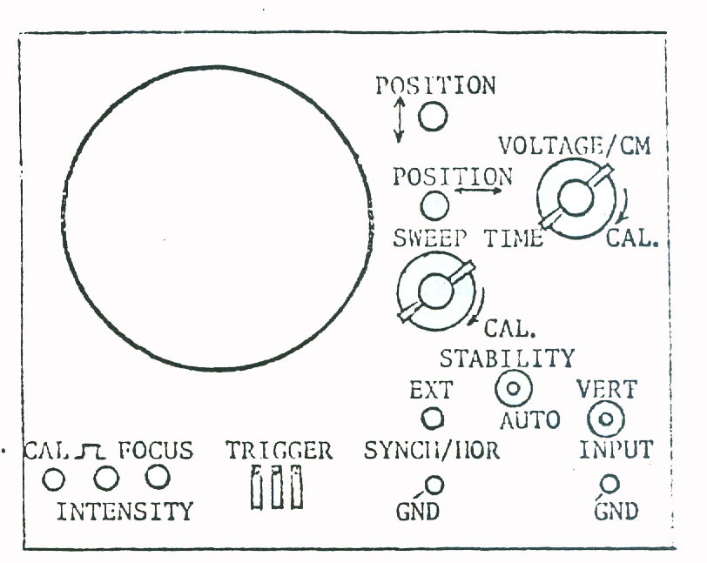
BRIEF INSTRCTIONS FOR BK 1460

Turn on the oscilloscope. After a brief warmup, a trace should appear on the screen. Turn the SWEEP TIME/CM switch clockwise to the EXT position, and the VOLTAGE/CM control to 20. The trace should be a single spot. Adjust the FOCUS and INTENSITY controls to produce a sharp spot of average brightness. Note that the electron beam can be adjusted up and down by means of the horizontal and vertical POSITION controls.

For normal use, set the controls as follows: all three TRIGGERING switches in the up position; VARIABLE knobs on the VOLTAGE/CM and SWEEP TIME/CM full clockwise (calibrated position); STABILITY control full counter-clockwise (automatic trigger level); 5X MAGNIFIER pushed in (off).

Turn the SWEEP TIME/CM switch full counterclockwise to 0.5 sec/cm. Turn the STABILITY control clockwise the initiate a slow sweep. Note that the beam moves slowly from left to right and then returns quickly. Increase the sweep speed until your eye can no longer see the electron beam move across the screen (note the sweep speed at which this occurs). Connect the CAL terminal to the V (vertical) INPUT and adjust the VOLTAGE/CM and SWEEP TIME/CM controls to display a square wave on the screen. From the calibrated setting, determine the amplitude and frequency of the square wave (they are nominally 5 volts peak-to-peak and 1 kHz, respectively). Return the STABILITY control to the automatic trigger position to obtain a stable display.

LISSAJOUS FIGURES

The frequency of an unknown wave can be determined by applying it to the vertical input and a wave of known frequency to the horizontal input. When the ratio of the vertical frequency (f_{y}) to the horizontal frequency (f_{x}) is a simple fraction, a Lissajous pattern results. A few simple Lissajous patterns are shown below; many more are illustrated in Sears and Zemansky, University Physics 3rd ed. (Addison-Wesley, 1964), p. 270.

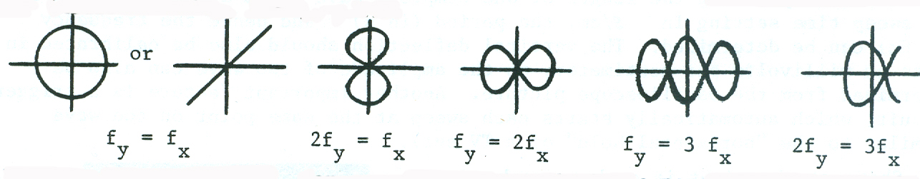

If the pattern F_{y} = 3f_{x}, for example, is traced with a pencil, it will be found that the pencil moves up and down three times for every time it moves across and back. If f_{y} and f_{x} are not exact multiples of each other, the pattern will “slip” with a frequency equal to the frequency difference between the signals. Some interesting effects are possible (pop art?!).

PROCEDURE

1. Adjustment of controls - Adjust the controls for normal use as instructed earlier. Determine the fastest sweep speed (sweep time/cm) at which the beam can be seen to move (this is a rough measure of the relaxation time of the phosphor coating on the screen).

2. Display of Square and Sine Waves - Connect the CAL terminal to the VERTICAL INPUT and adjust the VOLTAGE/CM and SWEEP TIME/CM controls to display a square wave. To determine the amplitude of the square wave, note its height in cm, and multiply by the number on the VOLTAGE/CM control.

To determine the frequency, first determine the period by noting the width in cm, and multiplying by the number on the SWEEP TIME/CM control. The frequency f is the reciprocal of the period T (i.e., f = I/T).

Connect the output from an audio generator to the VERTICAL INPUT. (Hint: to minimize noise, see that the ground terminals on the two instruments are connected together.) Adjust the various controls to display exactly two sine waves when the generator indicates f=500 Hz.

3. Lissajous Patterns - Turn the SWEEP TIME/CM switch fully clockwise to the EXT (external horizontal input) position. Supply a sine wave of 60 Hz to the horizontal input (EXT SYNCH/HOR) by means of a filament transformer. Adjust the frequency of the audio generator to obtain & circle (f_{x} = f_{y}); record the reading on the frequency dial. Adjust the frequency to 30 Hz and sketch the Lissajous pattern obtained. Repeat for f_{y} = 90, 120 and 180 Hz. Sketch the Lissajous pattern and record the reading on the generator dial in each case.

4. Observing Sound Waves - Connect a crystal microphone to the vertical input through a preamplifier. Sing, whistle, or speak into the microphone, and set the SWEEP TIME/CM and VOLTAGE/CM to display the resulting wave form. Also observe the sound from a tuning fork. How does it differ from the previous waveforms?

If time permits:

5. Measurement of Frequency - With the microphone on the VERTICAL INPUT, connect the audio generator you have calibrated to the HORIZONTAL INPUT. By means of Lissajous patterns, determine the frequencies of the two standard and the two unknown tuning forks.

DATA SHEET AND MINI-REPORT : Experiment 3

(To be used if a laboratory notebook is not kept)

1. Fastest sweep speed: (be sure variable control is at CAL setting)

2. Square wave height = cm setting in VOLT/CM =
(as seen):
amplitude = V

width = cm setting in SWEEP TIME/CM

Sine wave T (s or ms) =
(as seen):
f = Hz

3. Reading on frequency dial for f_{y} = f_{x}:

Lissajous patterns observed

f _{y} = 30 Hz 90 Hz 120 Hz 180 Hz

4. Sound waveforms
(as seen):

5. fork
f _{Hz}

